**GDC Norte: BTT e Caminhada**

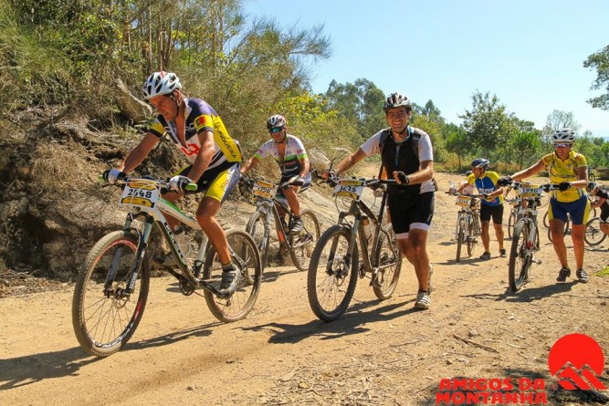

|  |  |  |  |  |  |  |  |  |  |  |  |  |  |  |  |  |  |  |  |  |  |  |  |  |  |  |  |  |  |  |  |  |  |  |  |  |  |  |  |  |  |  |  |  |  |  |  |  |  |  |  |  |  |  |  |  |  |  |  |  |  |  |  |  |  |  |  |  |  |  |  |  |  |  |  |  |  |  |  |  |  |  |  |  |  |  |  |  |  |  |  |  |  |  |  |  |  |  |  |  |  |  |  |  |  |  |  |  |  |  |  |  |  |  |  |  |  |  |  |  |  |  |  |  |  |  |  |  |
| --- | --- | --- | --- | --- | --- | --- | --- | --- | --- | --- | --- | --- | --- | --- | --- | --- | --- | --- | --- | --- | --- | --- | --- | --- | --- | --- | --- | --- | --- | --- | --- | --- | --- | --- | --- | --- | --- | --- | --- | --- | --- | --- | --- | --- | --- | --- | --- | --- | --- | --- | --- | --- | --- | --- | --- | --- | --- | --- | --- | --- | --- | --- | --- | --- | --- | --- | --- | --- | --- | --- | --- | --- | --- | --- | --- | --- | --- | --- | --- | --- | --- | --- | --- | --- | --- | --- | --- | --- | --- | --- | --- | --- | --- | --- | --- | --- | --- | --- | --- | --- | --- | --- | --- | --- | --- | --- | --- | --- | --- | --- | --- | --- | --- | --- | --- | --- | --- | --- | --- | --- | --- | --- | --- | --- | --- | --- | --- | --- |
| **Ficha de Inscrição** | | | | | | | | | | | | | | | | | | | | | | | | | | | | | | | | | | | | | | | | | | | | | | | | | | | | | | | | | | | | | | | | | | | | | | | | | | | | | | | | | | | | | | | | | | | | | | | | | | | | | | | | | | | | | | | | | | | | | | | | | |  | | | | | | |
|  | |  | |  | |  |  | | | |  | |  | | | |  | | |  | |  | |  |  | |  | |  | | |  | | |  | |  | | |  | | |  |  | | |  | |  |  | |  | | |  | |  | |  | |  | | | | |  | |  | |  | | |  | |  | | |  | | |  | | | | | | | |  | | |  | |  | | |  | | | |  | | | | |  | |  | | |  | |  | |  | | | | |  | |  | | | | |  | | | | | | | | |  | | |
| **Nome:** | | | | | |  |  | | | | | | | | | | | | | | | | | | | | | | | | | | | | | | | | | | | | | | | | | | | | | | | | | | | | | | | | | | | | | | | | | | | |  | | | **Nº Sócio:** | | | | | | | |  | | | | | | | | | | | | | | | | | |  | | | | | | | | | | | | | | | | | |  | | | |  | | | | | | |  | | | |  | | | | | | | | | | | | | | | | | | | | | | | | | | | | | | | | | | | | | | | |
|  | |  | |  | |  |  | |  | | | |  | | | |  | | |  | |  | |  |  | |  | |  | | |  | | |  | |  | | |  | | |  |  | |  | | |  |  | |  | |  | | |  | |  | |  | | |  | | | |  | |  | | |  | | |  | |  | | |  | | | | | | | |  | |  | | |  | | |  | | | |  | | | | |  | |  | | |  | |  | |  | | | | |  | |  | | | | |  | | | | | | |  | | | | | | | | | | | | | | | | | | | | | | | | | | | | |
| **Sócio:** | | | | | |  | |  | | | | | | | | | | | | | | | | | | **Não Sócio:** | | | | | | | | | | | | | | | |  |  | | | | | | | | | | | | | | | | | | | | | | | | | | | | | | | | | | | | | | | | | | | | | | | | | | | | | | | | | | | | | | | | | | | | | | | | |  | |
| **BTT/Prova30Km** | | | | | | | | | | | | | | |  | | |  | **BTT/Passeio18km** | | | | | | | | | | | | | | | | |  | | |  | | **Caminhada8km** | | | | | | | | | | | | | | | | | | |  | |  | | | | | | | | | **BTTCrianças2km** | | | | | | | | | | | | | |  | | |  | | | | |  | | |  | | |  |  | | |  | | | |  | | |  | |  | |  | |  | |  | | | | |  | | | | |  | | | |  | | | | | |  | |  |  |  | |  | |  | |  | | | |  | |  | |  | | | |  |  | | |  | |  | |  |  |  |  |  |  |  |  |  |
|  | | | | | | | | | | | | | | | |  | | | | | | | | | | | | | |  | | |  | | | | | | | | | | | | | | | | | | | | | | | | | | |  | | | | | | | | | | | | | | | | | | | | | | | | | | | | | | | | | | | | | | |  |  | | | | | | | | | | | | | | | | | | | | | | | | | | | | | | | | | | | | | | | | | | | | | |  | |  | |  | | | | | | | | | | | |  | | |  | |
| **Pagamento:** | | | | | | | | | | | | | | | | **Numerário** | | | | | | | | | | | | | |  | | | **Vencimento** | | | | | | | | | | | | | | | | | | | | | | | | | | | **TB – PT 0050 2179 000 107 983 3036** | | | | | | | | | | | | | | | | | | | | | | | | | | | | | | | | | | | | | | |  |  | | | | | | | | | | | | | | | | | | | | | | | | | | | | | | | | | | | | | | | | | | | | | |  | |  | |  | | | | | | | | | | | |  | | |  | |
|  | | |  | |  | | |  | | | |  | |  | | | | | | |  | |  | | |  | |  | | |  | | |  | | | |  | | | |  | | |  | | |  | | |  | |  | | |  | |  | | | | |  | | | |  | |  | | |  | |  | | | | |  | | |  |  |  | | |  | | |  | | | | |  | | |  | | | | | | |  | | | |  | | | | | | | | | | | |  | | | |  | | | | | |  | | | |  | | | | | | | |  | |  | |  | |  | |  | |  | |  | |  |  |  | | | | | | | | | | | | | | | | | |
| **Assinatura:** | | | | | | | | | |  | | | | | | | | | | | | | | | | | | | | | | | | | | | | | | | | | | | | | | | | | | | | | | | | | | | | | | | **Contacto:** | | | | | | | | | | | |  | | |  | | | | | | | | | | | | | | | **Data:** | | | | | | |  | | | | | | | | | | | | | | | | | | |  | | |  | | | | | |



O Núcleo Norte do GDC Fidelidade propõe aos seus associados uma prova de BTT e Caminhada a realizar no 25 de **Setembro** (Domingo), na Freguesia de Souselo, Concelho de Cinfães.

Saída do GDC – Norte, pelas 07H15, com destino a Souselo.

Oferta da organização: **Kit atleta.**

Porque um dos objectivos deste evento é a confraternização entre os intervenientes, no final da prova será servido um almoço organizado pela Associação **DUELO OCASIÃO.**

As inscrições deverão ser enviadas para o email: cesar.augusto.ferreira@fidelidade.pt, até dia **14 de Setembro**.

**Contamos com a vossa presença!**

|  |  |
| --- | --- |
| **Sócios** | **Não Sócios** |
| **5,00€** | **15,00€** |